LAPORAN SOAL PERBAIKAN NILAI NO.4
DASPRO


NADYA AURORA GEBI AGISTA
NIM 244107020034
KELAS TI 1H

PROGRAM STUDI D-IV TEKNIK INFORMATIKA
JURUSAN TEKNOLOGI INFORMASI
POLITEKNIK NEGERI MALANG
2024
- Flowchart charA – O
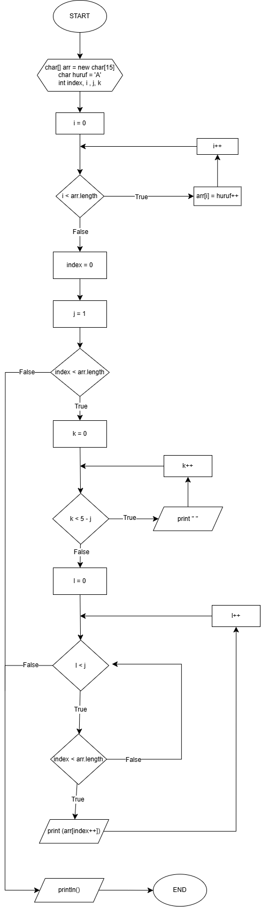

- Kode Program :
public class array1d {
public static void main(String[] args) {
char[] arr = new char[15];
char huruf = 'A';

for (int i = 0; i < arr.length; i++) {
arr[i] = huruf++;
}

int index = 0;

for (int j = 1; index < arr.length; j++) {
for (int k = 0; k < 5 - j; k++) {
System.out.print(" ");
}
for (int l = 0; l < j; l++) {
if (index < arr.length) {
System.out.print(arr[index++]);
}
}
System.out.println();
}
}
}

- Hasil Output :
